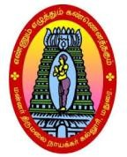
MANNARTHIRUMALAINAICKERCOLLEGE (Autonomous)
A Linguistic Minority Co-Educational Institution
Affiliated to Madurai Kamaraj University,Re-Accreditedwith‘A’GradebyNAAC
Pasumalai, Madurai-625004.

DEPARTMENTOFINFORMATION TECHNOLOGY

Course Name : Computing Fundamentals and C Programming Semester : I

Course Code : 21UITC11 Class : I B.Sc(IT)

ACTIVITY #1 : Power Point Presentation

Date : 13.09.2022

Topics : Unit I - II

Introduction : A paper presentation is an oral presentation for which topic are reported as part of the presentation.
Each paper presentation will be a maximum of 7 minutes in length and will be followed by a brief question and answer period of approximately 3 minutes.

Teams : 10 (each team contain 2 members)

Procedure : 1. Make the Presentation by given Topic

2.All member Should be explained them presentation

Snapshots of the Activity

